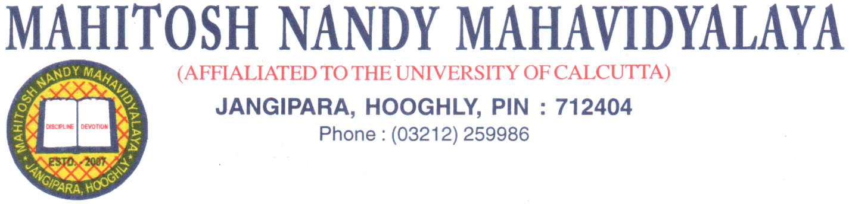
Ref. No……….. Date:……………………….
Lesson Plan
Department of Geography
Academic Year 2025
1. Semester/Year: Semester: I, III,V(CCF) July -December
2. Course Title & Content : weblink (syllabus will be uploaded on the college website
Assigned Teachers:  Course | Semester/Year | Assigned teachers
GEOG,MD-CC-01 | SEM-1 | Santanu Nandi & Swarnali Saha & Riya Das
GEOG,MD-CC-03 | SEM-3 | Santanu Nandi & Swarnali Saha & Riya Das
GEOG,MD-CC-06 | SEM-5 | Santanu Nandi & Swarnali Saha & Riya Das
GEOG,MD-CC-07 | SEM-5 | Santanu Nandi & Swarnali Saha & Riya Das
GEOG,MD-SEC-01 | SEM-1,3 | Santanu Nandi & Swarnali Saha & Riya Das
GEOG,-IDC-01 | SEM-1,3 | Santanu Nandi & Swarnali Saha & Riya Das

3. Course objectives& outcomes: (We blink)
4. Teaching hours: As per college routine (Link: https://mahitoshnm.ac.in/Routine.aspx)
5. Mode of Teaching: CCF: Lecture, ICT Enabled Teaching.1+1+1 System: Lecture, ICT Enabled Teaching.
6. Duration: As per the university guideline
7. Evaluation: (Under CCF)
i. Practical examination
ii. Theoretical examination

